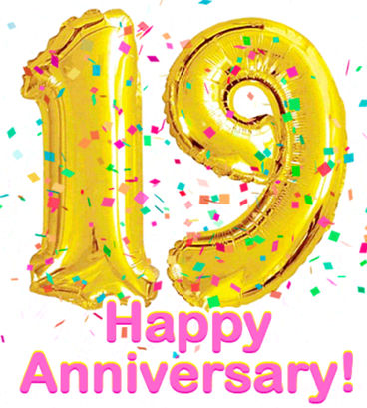
Clearview is Celebrating 19 Years
19 Things You Can Do This Year
To Change Your Health

What will you add to your life? Use this checklist to set some Goals for 2025 so that you can look back in 12 months and see some incredible steps you’ve made toward building your health!
- _____ Get Adjusted Regularly, We get 1 spine, we better take care of it!
- _____ Drink plenty of filtered/hydrogenated water, get Fluoride and other toxins out, Hydrogen H2O hydrates you & helps your gut bacteria
- _____ Get morning sunlight in your eyes, helps your circadian rhythm so that you sleep better later that night
- _____ Cut out processed breads, snacks and drinks (esp. enriched flours, high fructose corn syrup, dyes & all artificial flavors & colorings)
- _____ Read through the Whole Bible, Know the Truth, don't just take another man’s word for it, see what God said, Obey it & it will set you FREE
- _____ Daily work on your posture muscle/spinal strength, keep standing upright not slumping & if you slump, let this be the year you fix it
- _____ Do Intermittent Fasting regularly, helps control blood sugar, cravings & weight, Fasting is so good for us!
- _____ Put your bare feet on the ground daily, it helps so much with inflammation, and improves blood flow
- _____ Get sunshine directly on your skin, Vitamin D is crucial for your immunity + so much more
- _____ Pray every day before you get out of bed, giving God the first moments of your day sets the tone, surrender your life to Him
- _____ Work on your core strength, the best way to stabilize your spine and pelvis and help your balance, too
- _____ Choose the most natural skincare products, what goes on your skin goes IN you, Use on your skin things you’d be ok with eating
- _____ Get probiotics with fermented foods and/or take good probiotics daily, Healthy gut = healthy Digestion, Brain & Emotions
- _____ Say NO to food dyes & artificial flavors, these disrupt hormones & complicate ADD/ADHD + so many more detrimental things
- _____ Walk 20 minutes per day 3-4 times per week, it’s even better to take Several – 5 minute walks esp. after you eat; helps control blood sugar!
- _____ Cut out seed oils from your diet; seed oils take a massive toll on your health (these are corn, safflower, sunflower, vegetable & palm oils)
- _____ Give Thanks to God for everything you can think of each night before you go to bed, gratitude changes everything for the better, what better way to put your mind at rest thank to smile & give thanks
- _____ Start lifting weights & building muscle, Muscle is the currency of Longevity, live stronger & longer & better, avoid injuries & falls
- _____ Wear blue-light blocking glasses starting at sunset each evening, blue light massively effects your circadian rhythm and overall ability to fall asleep, blocking it will help you sleep & recover much better

